Abstract

This project is a mobile shopping system based on an existing store on the internet. The aim of this project is to provide a platform for online commerce. It is aimed towards benefitting physical business by providing clients to access products though internet. It enables to shop over the internet with the aid of any computer devices. The consumer receives his favorite products through online shopping and home delivery service. This system may be installed in any small business or in multi-international branded shop with retail outlet chain.

**Acknowledgement**

I take this opportunity to thank God for his favor and the completion of our effort. Thanks to Ms. Sachita our appreciated guide, I provide myself the proper direction and advice at the critical juncture and to show me right path. I would also like to thank the other faculty member.

**Table of Contents**

**Abstract** I

**Acknowledgement** II

**1.** **Project Introduction** 2

**2.** **EXISTING SYSTEM REVIEW:** 3

**3.** **STATEMENT OF PROBLEM:** 3

**4. Objectives** 3

**5. SCOPE:** 4

**6. Limitation** 4

**7. RESEARCH METHODOLOGY** 5

**7.1 FEASIBILITY ANALYSIS** 5

**7.1.1 Economic Feasibility** 5

**7.1.2 Schedule Feasibility** 5

**7.1.3 Technical Feasibility** 5

**7.1.4 Operational Feasibility** 5

**7.2 SOFTWARE DEVELOPMENT METHODOLOGY** 6

**8. Software Development** 8

**8.1 Use Case Diagram** 8

**8.2 Activity Diagram** 9

**8.3 Sequence Diagram** 10

**9. Database Design** 11

**9.1 ER Diagram** 11

**Project Introduction**

Online shopping or ecommerce is the process of purchasing various through the internet, directly from the vendor without any involvement of a middleman.

Online shopping is a great way to make several purchases and have them delivered to our location. As a result, we can consider online buying to be one of the most convenient modes of shopping. The merchants are constantly updating their website with product information. Online purchasing is lessening the crowds that were once common in markets. It saves the customer money and time while also providing a varied selection of options.

For people who don't have a lot of free time and are pressed for time at work, online shopping for mobile devices is the ideal solution. It's a convenient option for folks who can't stand shopping in busy areas or malls because they can order anything from the comfort of their own home or office. Physical purchasing does not provide the same variety of options as online shopping. You can look through many websites and select the product that best suits your needs. Online buying does not require real currency, and you can pay with your debit or credit cards, while cash on delivery is a possibility.

This project is aimed at developing a Web application that depicts online Shopping of mobiles and purchasing using Payment Gateway.

Using this software, companies can improve the efficiency of their services. Online Shopping is one of the applications to improve the marketing of the company’s products. Thisweb application involves all the features of the online shopping.

The goal of this work is to create a Web application that represents online mobile shopping and payment utilizing a Payment Gateway.

Companies can increase the efficiency of their services by using this software. One of the applications for improving the promotion of a company's products is online shopping. All of the functions of online purchasing are included in this web application.

**Existing System Overview**

Physical shopping for mobile devices is a time consuming and a tiring ordeal. Non-tech savvy individuals are prone to be fed incorrect information by the vendors and are also convinced to purchase inferior products compared to the competitions. They are not able to have a proper comparison between the devices of different brand and makes. They are not able to get information about the ideal device according to their budget and all the features they want.

**Statement of problem**

+++++++++++ `

**Objective**

* To provide a better platform for purchasing of mobile devices
* Provide proper detailed information
* To save customer’s time
* Increase sales

**Scope**

Many of the customers can buy different goods through this initiative. It can save the consumer time.

The system’s potential sizes are shown as follows:

• The current system may be expanded to enable users to create accounts and save the products in the list they want.

• Users may view prices so that different goods may be obtained.

• The current system is constructed up to the shopping cart operation. It is possible to expand the check-out method to be simple to use.

• Users may keep numerous information about shipment and invoicing. During the checkout you may pick the shipping and accounting details.

**Limitation**

* The project’s constraints are the following
* Time frame constraint.
* The whole manual system is difficult to assess.
* Difficult to implement the usage of the Internet by as many individuals.
* Not suitable to people with limited technical knowledge

**Research Methodology**

**Feasibility Analysis**

Following feasibilities were studied before building the system to see if the system could be built with exact requirements in the expected time.

**Economic Feasibility**

The system does not require use of any paid software and hardware i.e. it uses open-source technologies. This concept is based on a computer and laptop-friendly online system that is easy to use, accessible, and cost-effective. This cost-effective solution is built on computers running the Windows operating system. The project is cost-effective because the sole expense is a computer with the minimum parameters established previously. The only expense for users to utilize the application is that they must have Internet access.

**Technical Feasibility**

In order to design this system, it uses off-self and existing technologies, software and hardware so there is no technical hurdle to build this system.

**Operational Feasibility**

**Methodology**

We are going to use waterfall methodology [1] while building this web based system as this project is not so vast. This project has specific documentation, ample time, fixed requirement, well understood technology so in order to build this system, so waterfall methodology is best suited for this project.

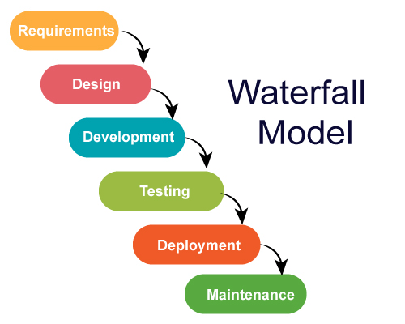

Figure 1: Waterfall Methodology

Functional and Non-Functional Requirement Specification

Functional Requirement

These are the requirements for the system and for the intended output to be carried out during specific actions.

• Users may register and log in to the rental and upload service. The functional criteria are:

• Users may produce things, read them, update them, and remove them (CRUD operation).

• Customers know exactly what they want and can search and filter.

Non-Functional Requirement

This is the non-functional requirement:

• The system should be trustworthy.

• For security purposes, the system should verify email and password.

• The system should be performing quickly and consuming less memory.

**Software Development**

**Use Case Diagram**

A use case diagram is a behavior diagram in UML. Use case diagrams model the functionality of a system using actors and use cases. Use cases are a set of actions, services, and functions that the system needs to perform. In this context, a "system" is something being developed or operated, such as a web site. The "actors" are people or entities operating under defined roles within the system. Use case diagrams are valuable for visualizing the functional requirements of a system that will translate into design choices and development priorities. They also help identify any internal or external factors that may influence the system and should be taken into consideration.

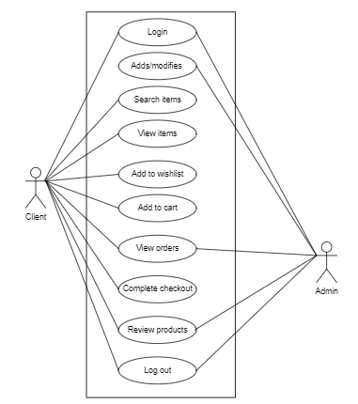

In the use case diagram for this web-based system, we have two actors – customer and admin. The admin can perform tasks such as viewing orders, managing categories and managing products. All the tasks done by admin are CRUD based operations. Whereas customer can view products by their categories, add items they like to wish list, add items to cart and manage their cart, place orders for goods and make purchase

**Activity Diagram**

An activity diagram is a behavioral diagram i.e. it depicts the behavior of a system. An activity diagram portrays the control flow from a start point to a finish point showing the various decision paths that exist while the activity is being executed.

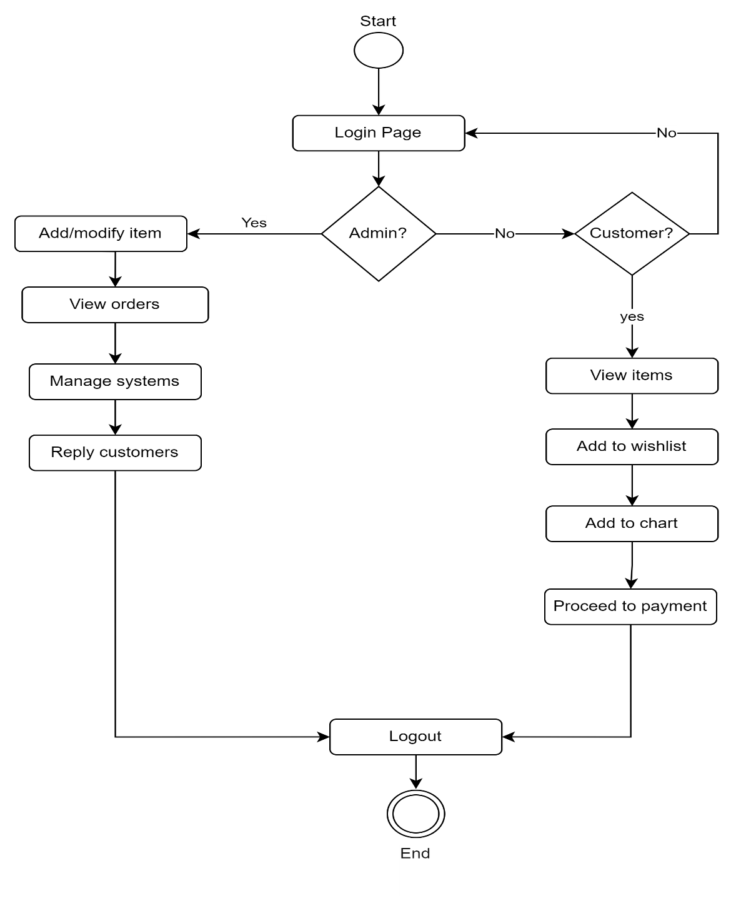

**Sequence Diagram**

A sequence diagram is a type of interaction diagram because it describes how—and in what order—a group of objects works together. These diagrams are used by software developers and business professionals to understand requirements for a new system or to document an existing process. Sequence diagrams are sometimes known as event diagrams or event scenarios.

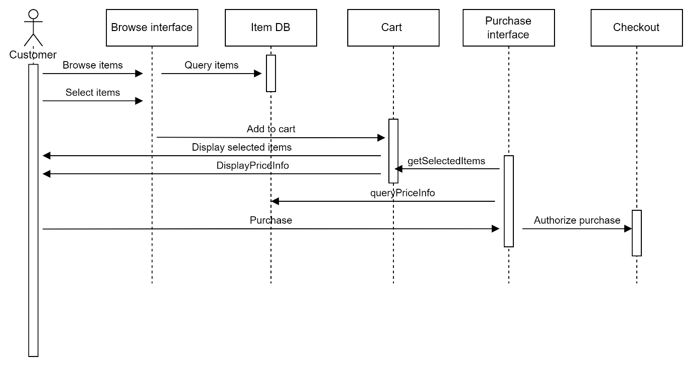

**Database Design**

**ER Diagram**

ER Diagram stands for Entity Relationship Diagram, is a diagram that displays the relationship of entity sets stored in a database. In other words, ER diagrams help to explain the logical structure of databases. ER diagrams are created based on three basic concepts: entities, attributes and relationships.

ER Modeling helps to analyze data requirements systematically to produce a well-designed database. So, it is considered a best practice to complete ER modeling before implementing database.

